**Task 1: Keyword Research for GlowSip Blog**

**What is GlowSip?**

GlowSip is a smart herbal water bottle brand that blends wellness with hydration. Infused with natural herbs like tulsi and ashwagandha, it helps promote glowing skin, energy, and daily balance. With the tagline “Glow Mode: Activated,” GlowSip turns every sip into a self-care ritual.

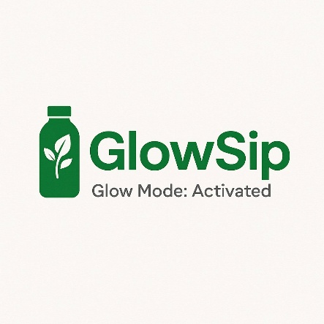

As part of the content strategy for GlowSip—a wellness brand focusing on smart herbal hydration—I conducted keyword research using **Google Keyword Planner** and **SEMrush** to identify **high-volume, low-competition keywords** relevant to our niche.

**Tools Used:**

* Google Keyword Planner
* SEMrush (for volume/competition analysis)

**Research Objective:**

To find targeted keywords for GlowSip’s blog that:

* Align with our product (herbal smart water bottle)
* Help boost organic reach
* Appeal to wellness-conscious audiences
* Support content that educates, inspires, and ranks

**Top Keywords Identified:**

| **Keyword** | **Monthly Searches** | **Competition** | **Intent** |
| --- | --- | --- | --- |
| smart water bottle | 33,000+ | Medium | Product discovery |
| herbal water benefits | 8,000+ | Low | Educational |
| hydration for glowing skin | 6,400+ | Low | Beauty + wellness |
| ayurvedic drink for daily use | 3,600+ | Low | Informational |
| natural detox water recipe | 9,000+ | Low | DIY / blog content |
| eco-friendly water bottle India | 1,800+ | Low | Commercial |

**Content Opportunity Examples:**

1. **"Glow Mode: Activated — How Herbal Hydration Improves Skin & Energy"**  
   (Focus: "hydration for glowing skin", "herbal water benefits")
2. **"5 Smart Ways to Stay Hydrated Naturally in 2025"**  
   (Focus: "smart water bottle", "natural detox water")
3. **"Ayurvedic Sipping: Daily Drinks That Heal from Within"**  
   (Focus: "ayurvedic drink for daily use")

**Keyword Strategy Summary:**

By targeting a mix of **short-tail** and **long-tail keywords**, GlowSip can:

* Rank better on search engines
* Gain **organic reach** on Google, YouTube, and Instagram
* Build a **credible wellness content hub** around hydration, glow, and herbal living